**Module No.4**

**COMPARISON AND CONTRAST**

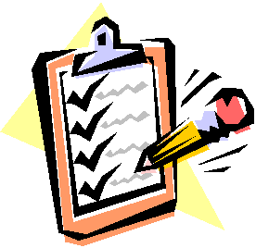

**Know Your Target**

1. Analyze and evaluate information by comparing and contrasting two different ideas.
2. Recognize and use compare-and-contrast text structure.

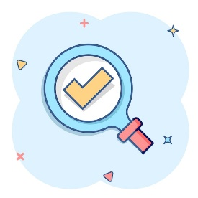

**Make a Jumpstart**

**How much do you know the two highest officials in our country?**

Write some similarities and differences between the incumbent president and vice president of our country.

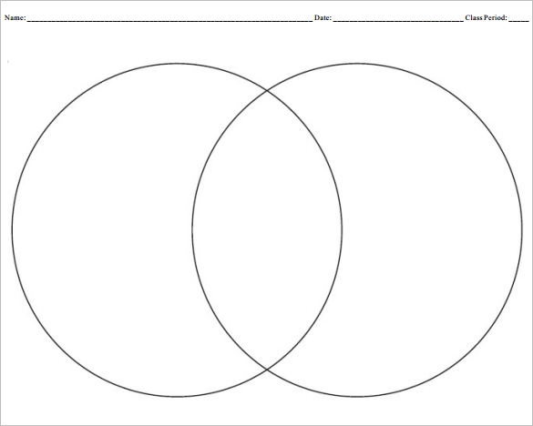

President Bongbong Marcos

Vice President Sarah Duterte

Similarities

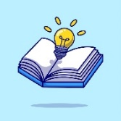

**Figure It Out**

COMPARISON AND CONTRAST

The ability to compare and contrast has its uses far beyond the classroom. With practical applications in everything from choosing which clothes to pack for a holiday or what books to read during your free time, comparing and contrasting are requirements for much of our everyday decision-making. However, when we discuss these terms in relation to reading skills, they have much more specific meanings.

**Comparison and Contrast** in reading is identifying the similarities and/or differences between two subjects. While comparing is the enumeration of similar features or characteristics, contrasting is the giving of conflicting or opposite descriptions. Exposure to various texts along with discussion is the best way to use this strategy to improve comprehension.

Developing a skill on comparative thinking helps us focus closely on the details in a text while improving our comprehension in the process. As a result, we enable ourselves to better retain the information we are reading. Likewise, this helps us understand how to organize information, think more clearly, and express ideas more effectively in their own writing.

Comparing is the giving of ideas,

A comparison and contrast text usually uses signal words.

When enumerating similarities, the following signal words are used:

**also similarly likewise**

**in the same way like both**

**same too alike**

**as the same as similar**

To show the differences, the following signal words are often used:

**unlike however in contrast**

**on the other hand on the contrary but**

**although yet whereas**

**while differ instead**

**contrary to in contrast the reverse**

Sorting out similarities and differences are helpful in understanding a text. Keywords and phrases may be used to determine the similarities and difference between two or more things.

A Venn diagram and other similar graphic organizers can be used to better understand a text of comparison and contrast.



**Do the Drill**

1. Below is a paragraph of comparison and contrast between books and movies. Try to enumerate the similarities and differences between books and movies by putting your answers in the graphic organizer.

Reading a book and watching a movie of the same story have a number of similarities and differences. They are similar as they both tell a story and give details and information about the narrative. Reading books or watching movies gives the reader and the viewer the same feeling and emotions about the story. Both require reader to understand what is happening to get the story. Books and movies have their own importance and it completely depends on people whether they prefer reading books or watching movies.

While reading books require readers to have a broad imagination and open their mind for thoughts and visions, movies give an image of the story to the viewers. Reading books requires dedication and time; on the other hand, watching movies can save time. While watching movies is easier, people still prefer reading books because they have more characters and suspense. Movie producers eliminate some characters and details about the story in order to squeeze everything into one to two hours. Also, watching movies provide superior picture about the story since it is visual and is within a short timeframe, so the audience can remember the story easier. Furthermore, you can do anything while watching movies. For instance, you can do your assignment while watching movies or cook food and watch movies. In contrast, you need to be fully focused on reading a book, or else you won’t understand what’s happening in the story. Reading books can not only enhance the readers’ vocabulary and creativity, but also increase their reading and writing skills unlike watching movies which only provides entertainment.

Books and movies have their own importance, and it completely depends on people whether they prefer reading books or watching movies. Their reasons can be different on their preference for books or movies, but whatever the reason is, reading books and watching movies have the same purpose in their life. Both tell a story and give details and information, and people read books or watch movies to entertain and utilize their leisure.

|  |  |  |
| --- | --- | --- |
| READING BOOKS | SIMILARITIES | WATCHING MOVIES |
|  |  |  |

1. 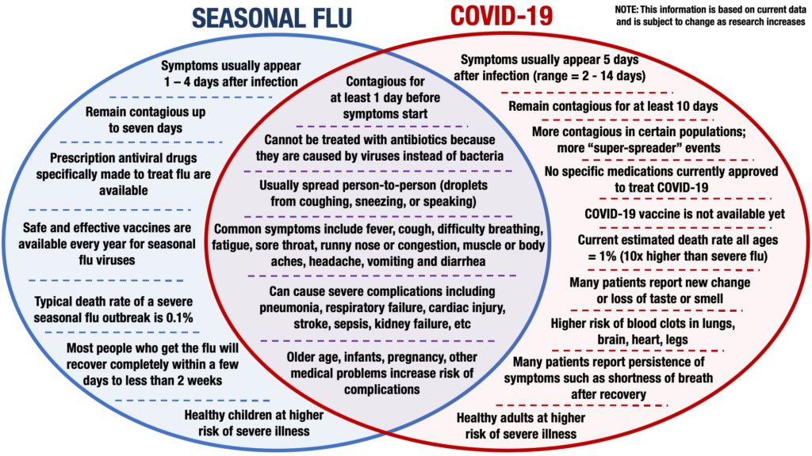The similarities and differences of COVID-19 and flu or influenza are shown in the diagram below. Convert it into a paragraph format, and write the information in complete sentences so that you form a unified and coherent paragraph.

Write your paragraph here:

_________________________________________________________________________________________________________________________________________________________________________________________________________________________________________________________________________________________________________________________________________________________________________________________________________________________________________________________________________________________________________________________________________________________________________________________________________________________________________________________________________________________________________________________________________________________________________________________________________________________________________________________________________________________________________________________________________________________________________________________________________________________________________________________________________________________________________

Science is discovery. A scientist proves statements using evidence. "This apple is red" becomes a scientific fact with an event or experiment that documents the reality that backs it. Scientists then build statements that predict facts without having to directly observe them. "All apples are red" would be an example of a predictive statement, and hence a theory. A green apple would easily prove it wrong so "apples fall from trees" would be a better theory.

Mathematics is computation. A mathematician solves problems and derives proofs by applying mathematical axioms to mathematical statements. Truth can only be translated, and never generated. Both sides of any equation are equally true. But this allows a mathematician to juggle the truth without ever breaking it. Mathematics describes the various shapes of any given truth.

Science seeks to understand some aspects of phenomena while math seeks to use logic to understand and prove relationships between quantities and objects. Science is discovery; a scientist proves statements using evidence. On the contrary, mathematics is computation where a mathematician solves problems and derives proofs by applying mathematical rules to mathematical statements. Mathematics is more related with calculations, but science is more related with working, reasoning, concepts behind everything.

both mathematics and science are taken as ways of understanding that are embedded in rational logic - focusing on universal knowledge statements. Both are seen by society in general as essential components of schooling,

With science and with the cooperation of mathematics, we gain a better understanding of the universe.

, and is based on empirical observations, mathematics is computation

ANSWER KEY



President Bongbong Marcos

Vice President Sarah Duterte

Similarities



* She is the Vice President of the Philippines.
* She is the Secretary of DepEd.
* She studied law and became a lawyer.
* He is the President of the Philippines.
* He heads the Department of Agriculture.
* He finished a course in business administration.
* Both are children of former Phil presidents.
* They both won the national elections by a landslide.
* Both are married to lawyers.
* Both have 3 children.

Answer Key:

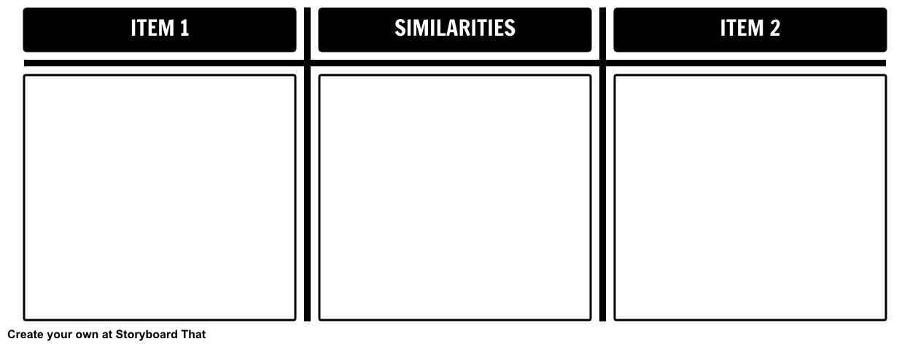

READING BOOKS

WATCHING MOVIES

* Reading books require readers to have a broad imagination and open their mind for thoughts and visions
* Reading books requires dedication and time.
* Reading books have more characters and suspense.
* In reading, the reader creates mental pictures.
* You need to be fully focused on reading a book
* Reading books can not only enhance the readers’ vocabulary and creativity, but also increase their reading and writing skills
* Movies give an image of the story to the viewers.
* Watching movies can save time.
* Movie producers eliminate some characters and details about the story.
* Watching movies provide superior picture about the story.
* You can do anything while watching movies.
* Watching movies only provides entertainment.

1. They both tell a story.
2. They both give details and info about the narrative.
3. They give the reader and the viewer the same feeling and emotions about the story.
4. Both require reader to understand what is happening to get the story.

References

*Teaching Compare and Contrast | Literacy Ideas*. (2021). https://literacyideas.com/compare-and-contrast/

‌